PROCEDURE: | Pruning – Crape Myrtles
INTENDED AUDIENCE: | LNR personnel pruning Crape Myrtles planted throughout campus.
PURPOSE: | To train LNR personnel on the correct technique to prune and maintain Crape Myrtles.
- Knowledge –
Before pruning Crape Myrtles, employee should have the ability of identifying the plant to be pruned and be familiar with the industry pruning standards for the plant. Employees should understand the criteria to determine if the Crape Myrtles needs to be thinned or trimmed.
- Safety –
- Check for any biting or stinging insect that might be in area to be pruned. If wasp/ants are a problem let the supervisor know, and have them treated if necessary.
- Follow the safety requirements for hand tools - specifically hand pruners, loppers and pruning saw.
- Personal Protective Equipment (PPE)
- Gloves are (recommended)
- Long sleeve shirt (recommended)
- LNR issued safety shoes (required)
- It is the employee’s responsibility to determine if added Personal Protective Equipment is needed and therefore must consult with their Supervisor prior to starting the task.
- Proper Outcome –
Pruning should promote plant health, encourage the growth and flowering aesthetics of the plant, and improve the appearance of the surrounding area.

- Steps for Trimming or Thinning Crape Myrtle-
- Identify the plant and assess if the Crape Myrtle will need trimmed or thinned out.
Note: Crape Myrtles are tough trees, so before pruning operations, ensure the loppers or hand pruner are clean and sterile and make good, clean cuts to prevent infection.

Note: When performing the assessment select three five or at the most, seven main trunks (an odd number of trunks are more pleasing to the eye than an even number). Also choose trunks that are strong, straight and have ample space to grow (see Diagram A).
- Using loppers or hand pruners, remove low branches at six (6) to eight (8) feet off the ground and all the way back to the main trunk (see Diagram A).
Note: If Crape Myrtle is located in an area that is not blocking traffic or hindering pedestrian traffic the pruning of the lower branches can begin lower.

CAUTION: Crape Myrtle should never be thinned, trimmed or clipped out using hedge shears. Using hedge shears can damage the plant and cause disease. Never cut into the trunk of the Crape Myrtle.

- Thin the crown of the Crape Myrtle by removing any branches that are growing in an area already occupied by another branch.
Note: Crape Myrtle crown will look best if the branches are spread in different directions.
- Prune upper branches by cutting slightly above a bud that faces the direction in which you want your new branch to grow.
- Remove any limbs that cross back through the plant or rub against each other (this will allow more sunlight and air circulation reducing the potential for diseases like powdery mildew).
Note: Do not “dead head” Crape Myrtle (see Diagram B). This practice may hurt blooming production.

CAUTION: Do not prune Crape Myrtle in the summer or fall. Summer heat can be stressful for new growth and if pruned in the fall, the new growth may be damaged by cold winter temperatures.

- Always disinfect pruners, loppers, or pruning saw between plants to prevent disease.
- When pruning operations are complete, clean the cutting edges of the pruners, loppers or pruning saw with disinfectant to avoid transfer of disease, and secure for the next use.
- Clean up all trimmings and dispose of in the proper designated area.

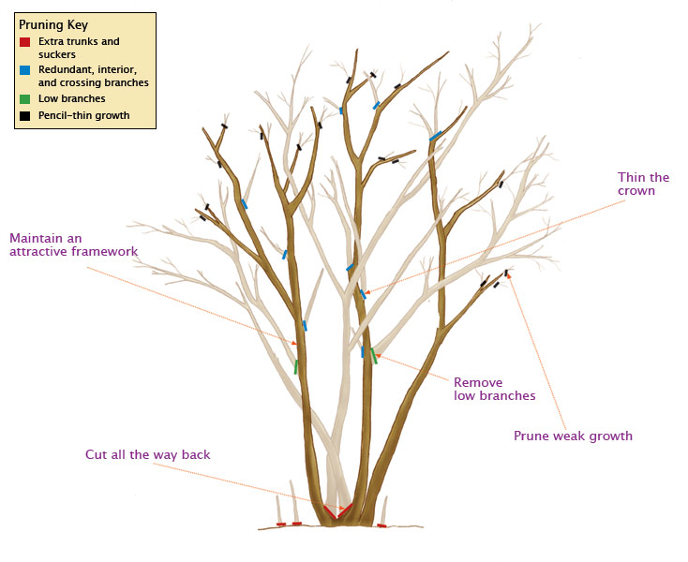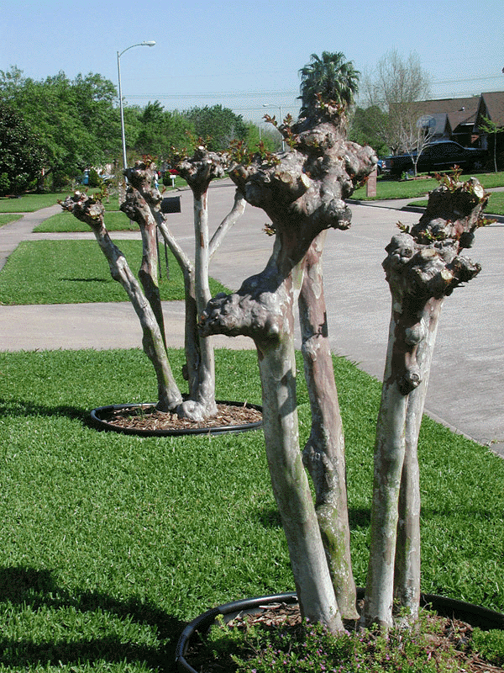
Correct Pruning Method
Diagram A
Incorrect Method (dead heading)
Diagram B

Note: It is not necessary to prune Crape Myrtles every year. It is recommended that they are pruned every two (2) to three (3) years.

